
Year 7 HASSL

/35
Task - Mapping & Practical Skills Test

NAME:___________________ Target: ___/35 or ____ %  
5 minutes reading and 35 minutes working time
General Mapping Skills.

- List the names of three types of maps. (3)

- __________________________________________________________
- __________________________________________________________

- __________________________________________________________

2. State what BOLTSS stands for. (6)

B - ________________________________

O - ________________________________

L - ________________________________

T - ________________________________

S - ________________________________

S - ________________________________

3. Differentiate between an alphanumeric grid reference and an area reference. Provide examples to support your response. (4)

_______________________________________________________________________________

_______________________________________________________________________________

_______________________________________________________________________________

_______________________________________________________________________________

_______________________________________________________________________________

4. What is the name of the vertical lines that form a grid on a topographic map?

________________________________ (1)

- What is the name of the horizontal lines that form a grid on a topographic map?

_________________________________ (1)

- Label the following diagram with the four cardinal and four intermediate points. (4 marks)

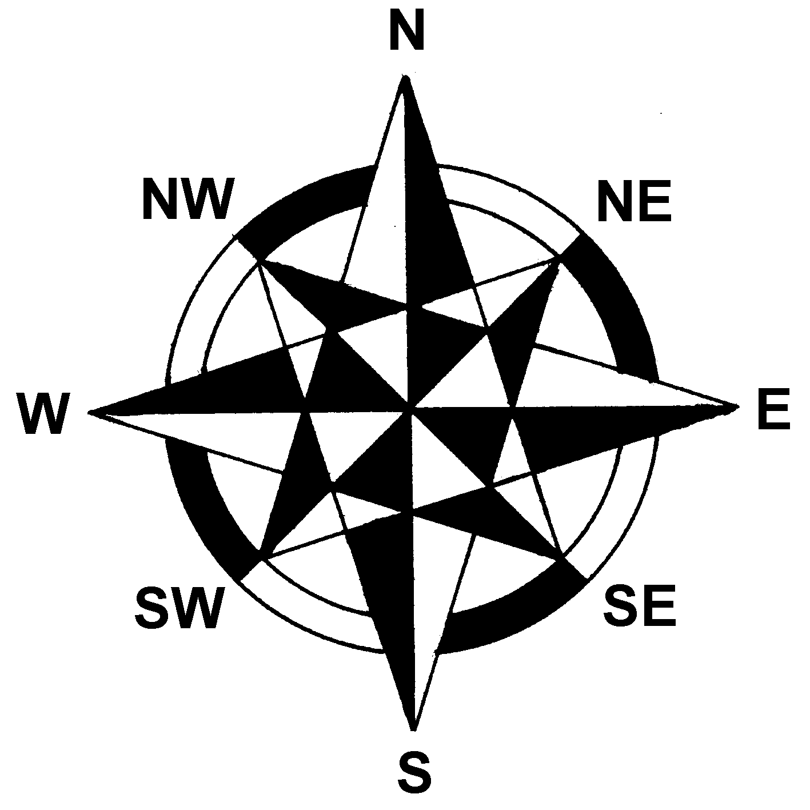
- Using the grid below, state the alphanumeric grid references for the following… (6 marks)

 |  |  | 
 | 
 |  | 
☒ |  |  | 
A B C D

 - _____________  - ___________
 - _____________  - _____________
 - _____________ ☒ - ___________

- Using the grid below, state the area references for the following…
(4 marks)

 |  |  | 
 | 
 |  | 
18 19 20 21 22

 - ____________________  - ____________________
 - ____________________
 - ____________________

- State the four ways scale can be shown. (4 marks)

- _____________________________________________________

- _____________________________________________________

- _____________________________________________________

- _____________________________________________________

- Outline ONE reason for why a person would use a map. (2 marks)

_______________________________________________________________________________

_______________________________________________________________________________

_______________________________________________________________________________

_______________________________________________________________________________

End of test paper

